EE3060 Probability – Proposed questions and answers

Question 1:

From an urn that contains a large number of red and blue chips, mixed in equal proportions, 10 chips are removed one by one and at random. The first red chip, together with all those that follow, is place in another urn that is initially empty. Calculate the expected number of the chips in the second urn.

Answer 1:

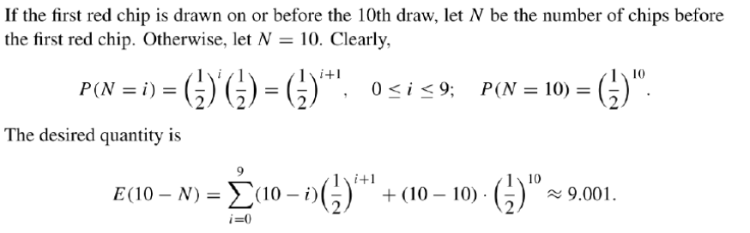

Question 2:

Q: Suppose the age of cars on the road is Normally distributed with a mean of 7.2 years. If the standard deviation is known to be 2.1 years, what is the probability that 12 randomly selected cars have been on the road for between 6 and 8 years?

Sol:

$$N\sim \left(7.2,\frac{2.1}{\sqrt{12}}\right)$$

We should fine the probability in the interval [6,8],

$$P\left(6≤X≤8\right)$$

$$=P\left(\frac{6-7.2}{\frac{2.1}{\sqrt{12}}}≤Z≤\frac{8-7.2}{\frac{2.1}{\sqrt{12}}}\right)$$

$$=P\left(-1.98≤Z≤1.32\right)$$

$$=0.9066-0.0239=0.8827$$

Question 3:

Suppose we extract an individual at random from a population whose members have an average income of $40,000, with a standard deviation of $20,000. What is the probability of extracting an individual whose income is either less than $10,000 or greater than $70,000?

Answer 3:

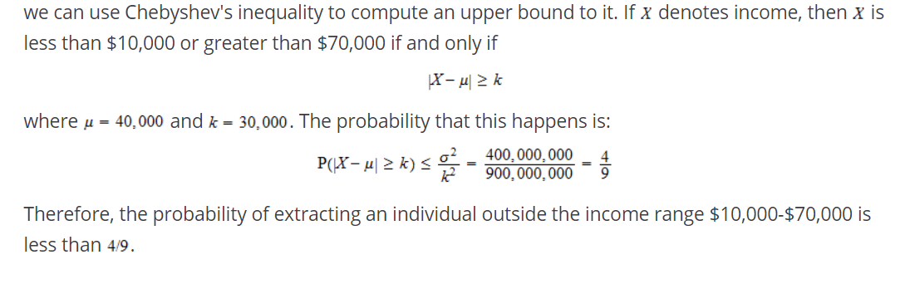

Question 4:

X is a r.v. take values between 0 and c.

Show that Var(x)≤ $\frac{c^{2}}{4}$

Answer 4:

E[X2]=

Var(X)= E[X2]-E[X]2≤cE[X]- E[X]2=c2[(E[X]/c)- (E[X]/c)2]

Question 5:

The bottle size of a student is X , which belongs to N(μ, $α^{2}$) ,where μ= 39.8cm and $α$ = 2.05cm. What is the probability that 5 of 20 randomly selected students have a bottle size of at least 40 cm?

Answer 5:

Let p = P(X $≥40$) = P($\frac{x-39.8}{2.05}≥\frac{40-39.8}{2.05}$) = 1-Φ(0.2236) = 0.46

What we ask p(A) = (${20 \atop 5}$) $p^{5}{(1-p)}^{15}$ =0.03